Indian School Al Wadi Al Kabir
Mid Term Examination
ENGLISH

Class: IX Time: 3 Hours
Date: 22-09-2022 Max. Marks: 80

General Instructions:
(i) All questions are compulsory
(ii) Please write down the serial number of the question before attempting it.
(iii) The question paper consists of three sections. Section A-Reading (20 marks), Section B-Writing (10 marks) and Grammar (10 marks), and Section C- Literature and Supplementary Reading Text (40 marks).
(iv) Attempt one section at a stretch and then move to the next section.
(v) Use of correcting fluid (whitener) is prohibited.

QI. Read the given passage carefully. On the basis of understanding the passage, answer the following questions. (1×10=10)

1. Cardamom, the queen of all spices, has a history as old as the human race. It is the dried fruit of a herbaceous perennial plant. Warm humid climate, loamy soil rich in organic matter, distributed rainfall and special cultivation and processing methods all combine to make Indian cardamom truly unique in aroma, flavour, size and it has a parrot green colour.
2. Two types of cardamom are produced in India. The first type is the large one, which has not much significance as it is not traded in the future market. It is cultivated in north-eastern area of the country. The second type is produced in the southern states and these are traded in the future market. These are mainly cultivated in Kerala, Tamilnadu, and, Karnataka. As per the future market rules, only 7 mm quality was previously traded in exchanges. But later, it relaxed its norms and now 6 mm quality is also traded in the exchanges.
3. Cardamom is an expensive spice, secondly to saffron. Indian cardamom is known in two main varieties: Malabar cardamom and Mysore cardamom. The Mysore variety contains leaves of cineol, and limonene and hence is more aromatic. India is the world’s largest producer and exporter emerged as the leading producer and exporter of cardamom.
4. The main harvest season of cardamom in India is between August-February. Cardamom reaches at yielding stage two years after the plantation. The primary physical markets of cardamom are Kumily Vandenmodu, Thekkady, Puliyarmala in Kerala and Bodynaikkaur and Cumbum in Tamilnadu.
5. Kerala is the main producer of cardamom and contributes up to 60% in total production. Karnataka produces around 25% of the total production of cardamom. Ooty is the main producer of cardamom in Tamilnadu and contributes around 10-15% of the total production. Besides India, Guatemala also produces around 1,000-2,000-ton cardamom per year. Due to low quality of cardamom from Guatemala, it remains available at cheaper rates.

1) Cardamom of Mysore variety contains leaves of:
(a) Limonene
(b) Cineol
(c) Both (a) and (b)
(d) None of these
2) Indian Cardamom is:
(a) Poor in quality
(b) Average in quality
(c) Better in quality
(d) Unique in quality
3) Cardamom produced in Guatemala is:
(a) Expensive but poor in quality
(b) Cheap but good in quality
(c) More and good in quality
(d) Cheap and poor in quality
4) Main harvest season of cardamom in India is:
(a) August-February
(b) August-March
(c) November
(d) February-April
5) Cardamom reaches at its yielding stage in:
(a) Immediately after plantation
(b) Depends upon the plantation
(c) One year after plantation
(d) Two years after plantation
6) India produces cardamom of:
(a) One type
(b) Two types
(c) Three types
(d) None of the above
7) Which of the following is the variety of Indian cardamom?
(a) Malabar cardamom
(b) Mysore cardamom
(c) Both (a) and (b)
(d) None of the above
8) What percentage of cardamom is produced by Karnataka?
(a) 25%
(b) 10%
(c) 15%
(d) 60%
9) Find the synonym of the word ‘distributor’ given in the passage 3.
(a) Expensive
(b) Known
(c) Producer
(d) Exporter

10) The synonym of the word ‘fragrance’ given in the passage 3.
(a) Aroma
(b) Variety
(c) Contain
(d) Hence

QII. Read the given passage carefully. On the basis of understanding of the passage, answer the following questions. (1×10=10)

More than 87,000 healthcare workers have been infected with Covid-19, with just six states – Maharashtra, Karnataka, Tamil Nadu, Delhi, West Bengal, and Gujarat – accounting for three-fourths
(around 74%) of the case burden and over 86% of the 573 deaths due to the infection, official data showed.
Maharashtra alone, with the highest number of over 7.3 lakh confirmed Covid cases so far, accounts for around 28% of the infected healthcare workers and over 50% of the total deaths, according to the data.
While Maharashtra, Karnataka, and Tamil Nadu had tested over one lakh healthcare workers each till August 28, Karnataka reported only 12,260 infected healthcare workers – almost half the burden in Maharashtra. Tamil Nadu reported 11,169 cases that included doctors, nurses, and Asha workers. The three states together accounted for 55% of the total cases among health workers.
Risk to frontline workers can jeopardise India’s Covid fight – The three states also reported the highest number of deaths in healthcare professionals, though with a wide gap between Maharashtra and the other two. While Maharashtra reported 292 deaths among healthcare workers, Karnataka and Tamil Nadu had 46 and 49 deaths, respectively.
A large number of infections and even deaths of healthcare workers in particular states is being viewed with concern by officials and public health experts, who say risks to frontline workers can jeopardise India’s fight against the pandemic
The issue, discussed in a review meeting headed by the cabinet secretary on Thursday, saw the Centre cautioning states about the need to protect a crucial resource. The possible factors responsible for high infections, officials said, were lax infection control in hospitals and the need for stringent containment measures in areas where health professionals reside to safeguard them. Despite the high number of cases, the government has received only 143 claims since April under the ₹ 50 lakh Covid-19 insurance scheme for healthcare workers engaged in Covid mitigation activities.
Official sources said the wide gap between the number of deaths and claims could be because all the casualties may not be eligible under the scheme. Besides, the claims are a bit slow in coming as families of the dead take time to apply and do the required paperwork.
Solidarity with health workers cannot be met with mere words of encouragement but by concerted efforts to strengthen the health workforce. Safety net for their families should be provided including a term insurance cover of over ₹ 2 crores, with the government as sole guarantee,’ said Giridhar Babu, epidemiologist at the Public Health Foundation of India.
‘ ‘Protecting healthcare workers is of paramount importance to make sure we have a large enough force to take care of patients who need their services.’ said Dr. H. Sudarshan Ballal, chairman, Manipal Hospitals, who said such workers may be at risk because of a large number of asymptomatic patients and lack of proper use of PPEs.
(Source: The Times of India/Health Ministry)

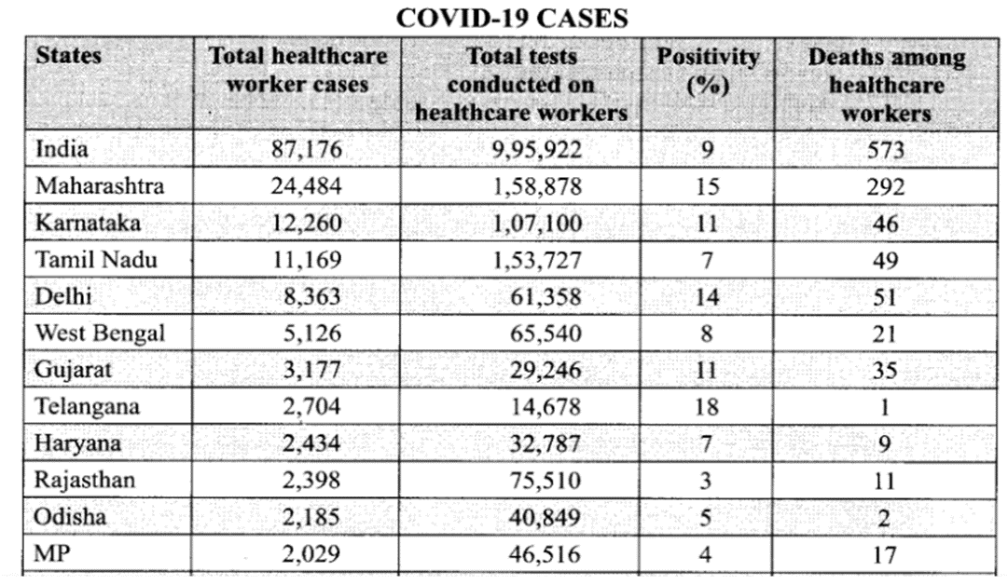

1) In the line “………risks to frontline workers”, the term ‘frontline workers’ does not refer to:
(a) healthcare workers
(b) police
(c) cleanliness workers
(d) teachers
2) Based on your understanding of the passage, choose the option that lists the factors responsible for high infection in healthcare professionals.
1. Careless infection control in hospital
2. Due to negligence by health care professionals
3. Lack of stringent containment measure
4. Due to the lack of healthcare professionals
(a) 1 & 2
(b) 2 & 3
(c) 1 & 3
(d) 2 & 4
3) What is the correct meaning of the word concerted as used in the passage?
(a) Individual
(b) collaborative
(c) separated
(d) exclusive
4) Choose the option that lists a statement that is NOT TRUE.
(a) Maharashtra is the worst sufferer of Covid-19.
(b) Karnataka has a smaller number of Covid-19 cases as compared to Maharashtra and Tamil Nadu.
(c) The deaths of healthcare workers are disregarded by officials.
(d) Most of the families of deceased healthcare workers received 50 lakhs under Covid-19 insurance scheme.
5) How many health workers have been infected with COVID-19 in Maharashtra as per the graph?

6) How many healthcare workers have died in Rajasthan due to COVID-19 infection?
7) Which state of India is on the top in terms of confirmed COVID-19 cases?
8) How many healthcare workers infected with COVID-19 are there in Karnataka till August 2020?
9) How many claims has the government received since April 2020 under the ₹ 50 lakhs COVID-19 insurance scheme for healthcare workers engaged in COVID-19 alleviation activities?
10) How many healthcare workers died in Karnataka due to COVID-19 infection?

SECTION B - WRITING AND GRAMMAR (20 marks)

QIII: Answer the following questions (2x5=10 marks)

(i) Your brother has turned up from abroad after his higher studies. Your all family members celebrated his arrival. Write a diary entry describing how you gave a homecoming welcome to your brother and soon that day became ‘A Memorable Family Occasion’ for you.
(ii) Seema decided to write a story for her school magazine. But after some time, she could not complete her story as she had to go out for urgent work.
Complete the story on the basis of the beginning given below with 100-200 words.
“An old man had two daughters. He loved both of them. Once he asked them ……..

QIV: Complete the following sentences using an appropriate tense form. (3x1=3marks)

1. Ramesh was hungry so he __________(cry)
2. He had been _________(read) since morning.
3. We ______ (travel) Hyderabad by bus, two weeks ago.

QV. Fill in the blanks with the appropriate form of the modals. (1x4=4marks)

Ruby: Papa, I have not seen Qutab Minar, we (a) ……………………. visit it.
Papa: Yes, we (b) ……………………. all go together next week and (c) ……………………. not forget it.
Ruby: (d) ……………………. I remind you, papa?
Papa: No child, I shall remember to plan the visit.
(a) will, must, could, shall
(b) will, ought to, can, should
(c) could, must, should, would
(d) may, should will, might

QVI. Fill in the blanks with suitable determiners. More than one answer is possible in certain
cases. (1x3=3 marks)
1. I know very …………………... about him.
2. …………………... side of the square has the same length.
3. I collected all the marbles but I think …………………... are still left.

SECTION C: LITERATURE AND SUPPLEMENTARY READER (40 marks)

QVII. Read the extract given below and answer the following questions (10x1=10 marks)

(A) “What’ll I do if I have a nightmare?” she asked. “I often have nightmares and then Grannie takes me into her bed- I can’t stay in the dark- it all gets ‘whispery’…”

1. Who said this to whom?
2. Name the story and its writer.
3. Did the speaker get another nightmare? Who helped the speaker?
4. Why was the grandmother not there for the speaker?
5. What was the nightmare about?

(B) “He won’t do what you tell him.
So, come, let’s build strong homes,
Let’s joint the doors firmly.
Practice to firm the body.

1. Name the poem and the poet.
2. Who is referred to as ‘he’ in the above lines?
3. Why will he not listen to the poet?
4. Which figure of speech is used in the first line of the given extract?
5. What is the rhyming scheme of the given poem?

QVIII. Answer ANY FOUR of the following questions in 30-40 words (4x2=8 marks)

(i) When and what did Margie write in her diary?
(ii) When and how did Bismillah Khan get his big break?
(iii) At what price was Toto bought by the grandfather and from whom?
(iv) In what way is Iswaran an asset to Mahendra?
(v) Who noticed Evelyn’s deafness and at what age?
(vi) Where did the child lose his parents? Who found him?

QIX. Answer ANY FOUR of the following questions in 60-80 words (4x3=12 marks)

(i) Describe Iswaran’s amazing capacity to produce vegetables.
(ii) Describe the county inspector. Why was he called?
(iii) In the fair, the child wants many things. What are they? Why does he move on without waiting for an answer?
(iv) The poet finds himself at a crossroad. Describe the two paths at the crossroad in the forest.
(v) “Toto was a pretty monkey.” In what sense was Toto pretty?
(vi) Describe Kezia’s father as she saw him.

QX. Answer ANY TWO of the following questions in 100-120 words (2X5=10 marks)

(i) Give a character sketch of Iswaran.
(ii) What damage did the wind cause? How can it be avoided?
(iii) Describe the situation in which grandfather found himself at the Saharanpur railway station.
(iv) How did Kezia’s negative attitude towards her father change?

